[day 1 task.docx](day%201%20task.docx)

Filecreation

[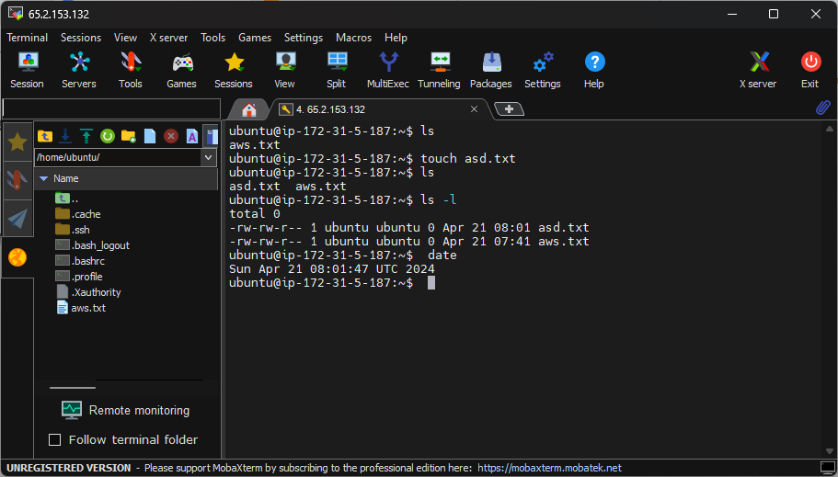](file%20creation%20Screenshot%201.png)

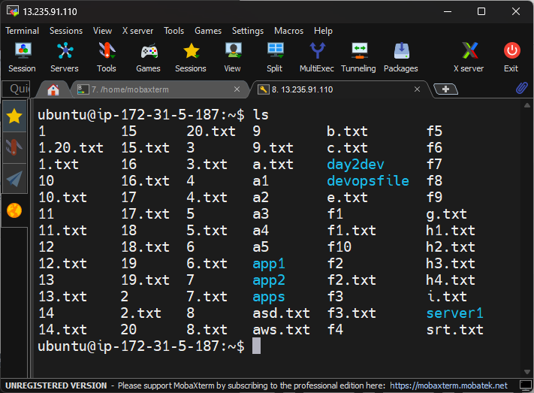

File print

